Instructions for iMPROve Health’s Secure File Exchange
http://www.sendthisfile.com/mpro

FIRST-TIME USERS:
1. After clicking the link above, you will get this screen. Click Request access and follow just a few simple steps to get registered.

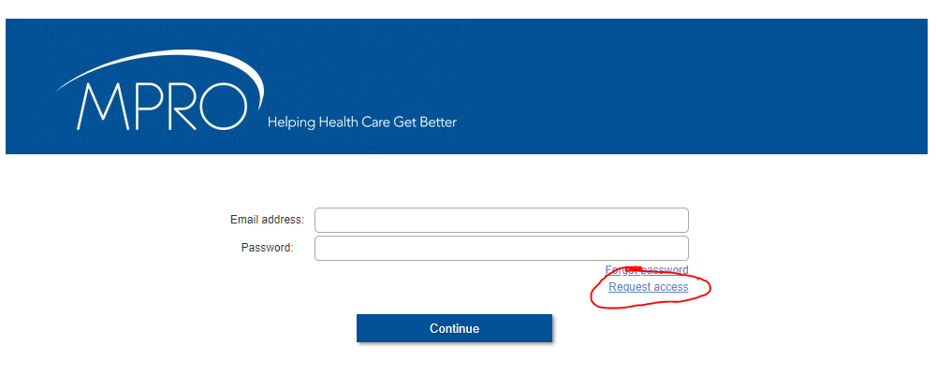

You will now get this screen:

2. Type in your preferred email address, choose and type your password, retype it under Confirm: and then click Register. Please don’t share your password with anyone.
3. An email verification link will be sent to the email address you used to register. Follow the link in the email to verify registration.

4. Once verified, you are now set up to receive and send files.

RECEIVING FILES FROM iMPROve Health
1. You will receive an email message that looks like this:

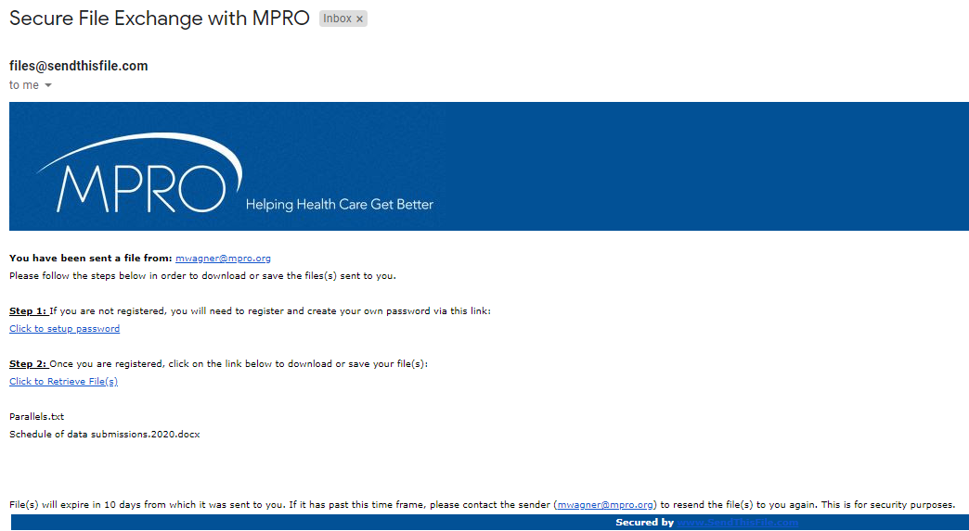

2. If you’ve already registered, skip to Step 2. If not, go back to the above instructions and register.

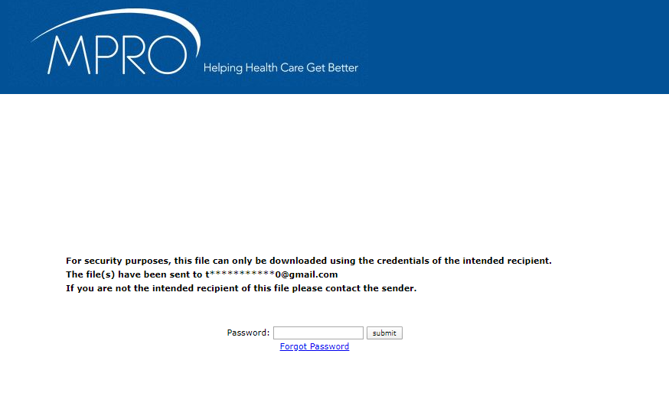
3. At Step 2, click on the blue hyperlink that says “Click to Retrieve Files,” and you will see this screen:
4. Type in your password (make sure it is the one corresponding to the email address you used to register for SFE) and click submit. You should now see a screen that looks like this:

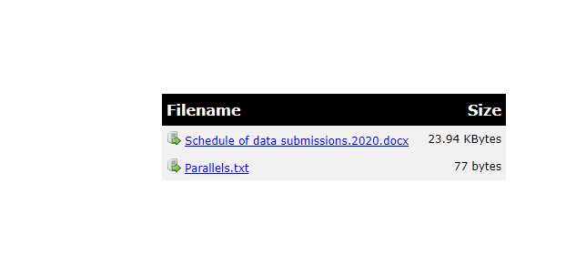

5. All files you need to review will be listed under Filename. Click on each file individually, and save it to a secure place on your computer.

SENDING FILES TO iMPROve Health
1. Go to the website https://www.sendthisfile.com/mpro to get this screen:

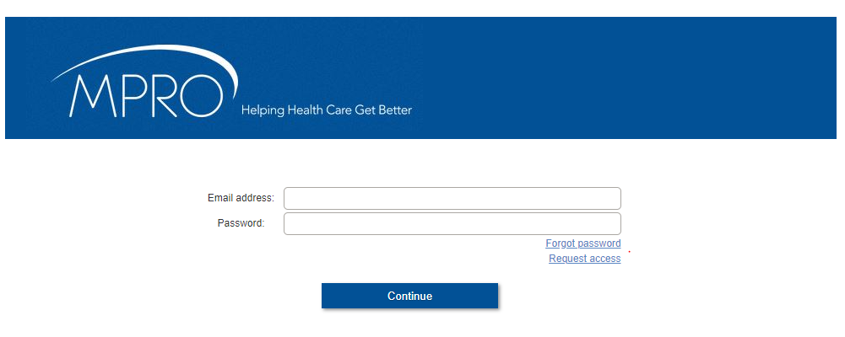

2. Login with your email address and corresponding password you used to download the files, and click Continue.
You should now see this screen:

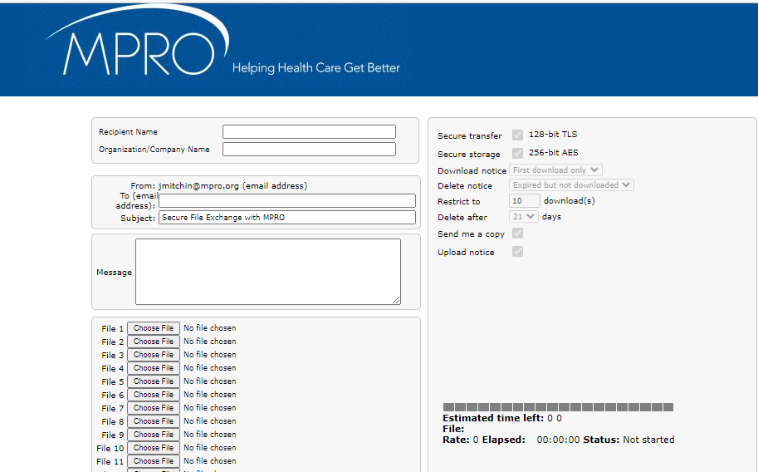

TO SEND YOUR FILES BACK TO iMPROve Health, USE THIS GUIDE:
- Recipient name: IRO Team
- Organization/Company Name: iMPROve Health (optional)
- From: your email address should populate automatically
- To (email address): please use IRO@improve.health
- Message: optional.
- Click the first “Choose File” on the list (below the Message box). This should take you to a directory of files on your computer. Select and click on the appropriate file to upload it into Secure File Exchange. Repeat this process for each file you want to send.
- You can upload up to 20 files at a time.
- You can also upload your timesheet and Conflict of Interest Attestation as files.
- When done uploading all files, click SendThisFile at the bottom of the screen.

- You will get an email confirmation informing you that the files have been uploaded.

SECURITY ALERT: PLEASE DO NOT PUT PROTECTED HEALTH INFORMATION (PHI) IN THE SUBJECT LINE OR MESSAGE AREA. EMAILS ARE GENERATED TO THE SENDER AND THE RECIPIENT WHENEVER YOU USE SECURE FILE EXCHANGE, AND EMAILS ARE NOT CONSIDERED A SECURE METHOD OF TRANSMITTING PHI.

QUESTIONS?

Contact:
Leslie Howard, MHA, MSN, RN, NE-BC, lhoward@improve.health, or at 248-465-7373 (office)

THANK YOU!!

